Global Economic and Demograhic Trend Analysis

**Project Overview:**

This project analyzes **global economic and demographic trends**, focusing on GDP growth, population changes, birth and death rates, and sectoral contributions. It examines how different factors such as industry reliance, literacy rates, and healthcare access impact economic stability across various countries. Interactive **Power BI dashboards** and **based insights** help visualize key trends for better decision-making.

**Dataset Description:**

* **SQL Database**
  + Countries World
* **Excel Files:**
  + GDP by Country(1960-2016).
  + Population Per Country-csv file.
  + Meta Data by country-csv file.

Key Features:

Country wise economic and demographic data.

Time range covering several decades(1960-2016)

* Key metrics include:
* GDP per capita
* Population growth rates
* Life expectancy
* Urbanization rates
* Population Density
* Literacy rates

**Data Cleaning:**

* Duplicate Removal: Removed repeated records to maintain data integrity.
* Handling Missing Values: Used imputation or deletion based on data relevance and availability.
* Data Reshaping: Unpivoted and appended data to align with analytical needs.
* Standardization: Ensured uniform formats for dates, numbers, and categories.
* Validation: Cross-verified processed data to ensure accuracy and reliability.

**Descriptive Statistical Analysis:**

Basic descriptive statistics were used to summarize and understand the data, including:

* Mean, median, and mode for key indicators.
* Distribution analysis for GDP, life expectancy, and population growth.
* Identification of trends and outliers over the decades.

**Dax Function:**

* GDP Growth Rate
* Calculated columns for GDP per capita.
* Population growth rate over time
* Regional aggregations and comparisons

**Dashboard**

Dashboard1: Global overview

* + GDP per capita trend by country.
  + Agriculture vs Industry vs Service by country.
  + Visualized GDP growth over time.
  + Infant mortality and GDP correlation.

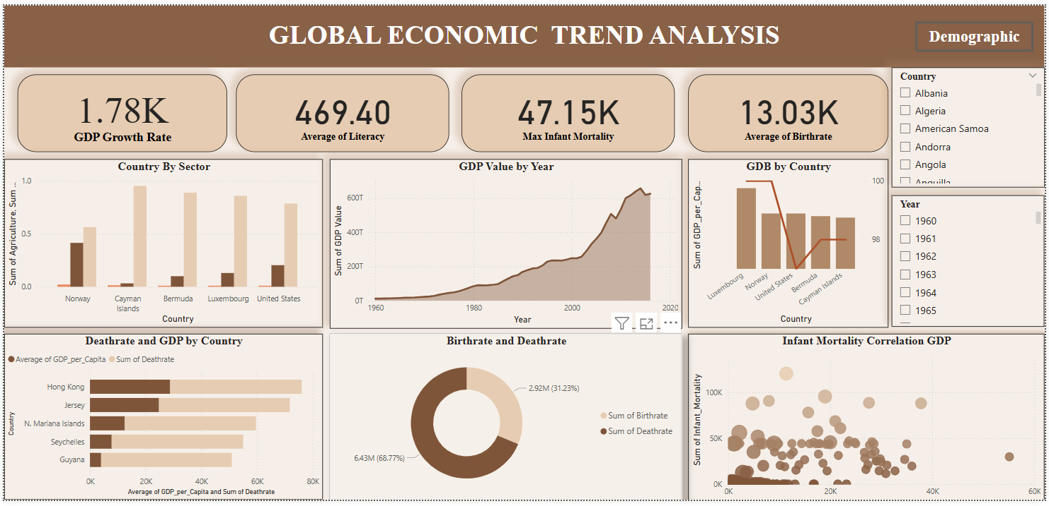

Dashboard2: Economic Overview

* Population growth over time.
* Population distribution by income group.
* High Population by country.

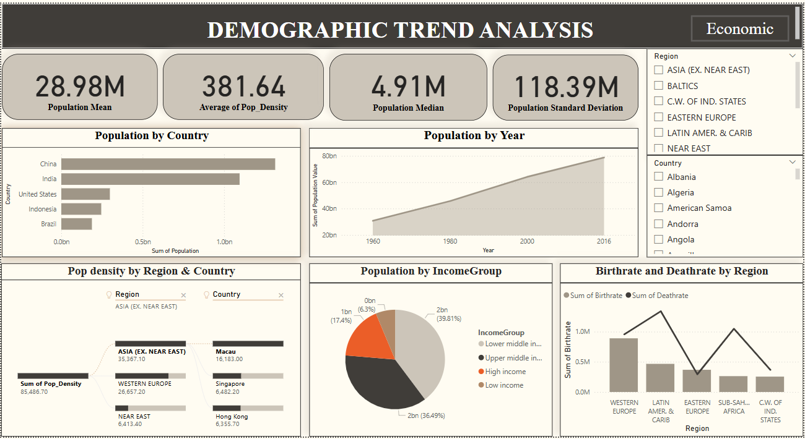

Insights:

GDP Growth Trend:

* GDP Growth Rate Fluctuations Over Time
* The GDP Growth Rate chart shows high volatility, especially after 2000.
* A growth rate of 1.11% in 2016 suggests slower expansion.

Population Growth Trend:

* The population is increasing over the years, potentially due to improved living conditions, economic growth, and medical advancements.

High GDP Per Capita in Developed Nations:

* Luxembourg, Norway, and the United States have the highest GDP per capita.
* This suggests strong economic development and industrialization in these nation.

Western Sahara as the region with the lowest GDP:

* The region has a small population with limited access to higher education and skilled labour.
* Many people migrate to Morocco or other countries for work.

Birthrate & Economic Stability:

* Countries with higher GDP per capita tend to have lower birthrates.
* Developed nations have lower birthrates, while developing nations have higher birthrates, often due to lack of access to healthcare.

Infant Mortality & Healthcare Access:

* Countries with higher GDP have lower infant mortality rates due to better healthcare infrastructure.

Literacy Rate & Economic Development:

* Higher literacy rates are strongly correlated with higher GDP. Educated populations contribute to technological advancement, innovation, and workforce productivity.

**Recommendation:**

Improve Education and Literacy Rate:

* Higher literacy leads to better job opportunities and GDP growth.
* Increase government spending on education (technical, vocational, higher education).
* Boost digital literacy & technology adoption to enable a knowledge-based economy.

Invest in Healthcare & Reduce Infant Mortality:

* Increase public healthcare spending to improve life expectancy and productivity.
* Reduce infant mortality rates through improved maternal care and vaccination programs.
* Strengthen mental health services & employee wellness programs to enhance workforce efficiency.

Support Economic Diversification:

* Countries dependent on a single industry (e.g., oil, agriculture) should expand into **tech, finance, and manufacturing**.

Urban Development & Infrastructure:

* High-density regions need smart city planning to sustain population growth.

Foster Foreign Investment:

* Encouraging investments in **developing economies** can boost GDP and reduce poverty.
* **Increase Agricultural Productivity** – Modernize farming and supply chains

**Conclusion:**

This analysis provides valuable insights into the long-term evolution of global economies and population dynamics, highlighting key changes in economic performance, demographic transitions, and social development over time. By recognizing these trends, policymakers, economists, and researchers can better understand the historical context of current global conditions. These insights also serve as a strong foundation for predicting future trends, enabling data-driven decision-making and the creation of strategic policies to tackle emerging economic and demographic challenges.